19CSE305
MACHINE LEARNING
CUSTOMER CHURN PREDICTION

NAME | ROLL NO
HRITHURAG SUNDAR | CB.EN.U4CSE21125
UDAY KIRAN | CB.EN.U4CSE21129
HARISH SIDDHARTH | CB.EN.U4CSE21149
S.SANJEY | CB.EN.U4CSE21150

- URL OF DATASET

https://www.kaggle.com/code/bhartiprasad17/customer-churn-prediction/input

- DATASET DESCRIPTION (ATTRIBUTE DETAILS)

Customer Churn prediction means knowing which customers are likely to leave or unsubscribe from your service.

ATTRIBUTE DETAILS :
- CustomerID : This attribute is a unique identifier and is not directly relevant to churn prediction. It primarily serves as an identifier and should not influence the churn prediction itself.

- Gender : While gender may have some indirect influence on churn (e.g., different preferences or behaviors), it is generally not a strong predictor of churn on its own.

- SeniorCitizen : This attribute could be relevant because senior citizens might have different churn patterns due to their unique needs and preferences. It may be a valuable predictor in your churn prediction model.

- Partner and Dependents : These attributes can be relevant because customers with partners or dependents may have different motivations and reasons for churn compared to those without. They can be useful predictors.

- Tenure : Tenure is likely to be a significant predictor. Longer-tenured customers may be less likely to churn compared to newer customers, as they have a more established relationship with the company.

- PhoneService and MultipleLines : These attributes are relevant as they reflect the type of phone service the customer has, which could affect their overall satisfaction and likelihood to churn.
- InternetService : The type of internet service is highly relevant. For example, customers with high-speed fiber optic internet may have different churn behavior compared to those with DSL.

- OnlineSecurity, OnlineBackup, DeviceProtection and TechSupport : These attributes are crucial as they relate to the availability of services that enhance customer experience and security. Customers lacking these services may be more likely to churn.

- StreamingTV and StreamingMovies : These attributes are relevant, especially if they contribute to the overall value proposition of the service. Customers who use streaming services might have different churn patterns.

- Contract : This is a highly relevant attribute. Customers with longer-term contracts are typically less likely to churn compared to month-to-month subscribers.

- PaperlessBilling : This attribute can be relevant, as customers with paperless billing may have different preferences and behaviors compared to those receiving paper bills.

- PaymentMethod : Payment method can be relevant, as it may indicate financial stability and preferences. Some payment methods may be associated with higher churn rates.

- MonthlyCharges : Monthly charges are relevant because higher charges could lead to increased churn if customers perceive them as too high for the value received.

- TotalCharges : This attribute can be relevant if it represents the total accumulated charges over the customer's lifetime. It may capture long-term value and loyalty.

- Churn : This is the target variable, and the most important attribute for churn prediction as it indicates whether a customer has churned (YES) or (NO).

- VISUAIZATION OF DATASET-INFERENCE OF EACH GRAPH

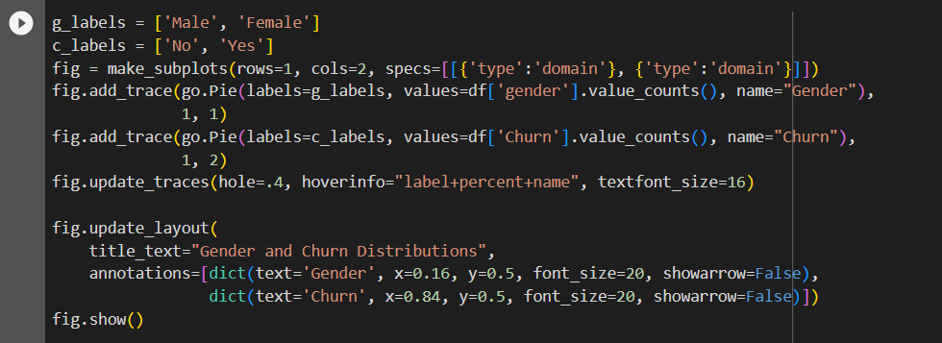
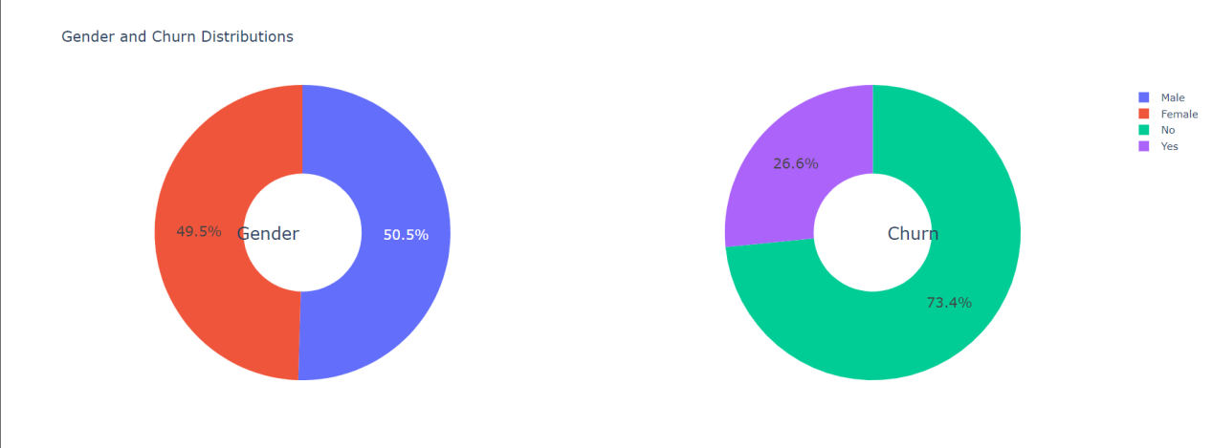

- 26.6 % of customers switched to another firm.
- Customers are 49.5 % female and 50.5 % male.

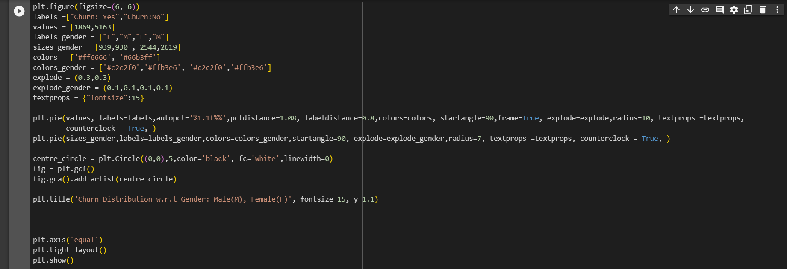
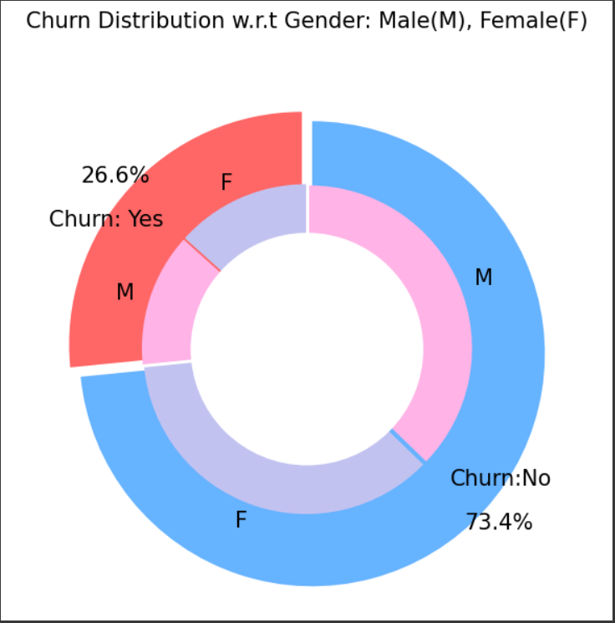

- There is negligible difference in customer percentage/ count who changed the service provider. Both genders behaved in similar fashion when it comes to migrating to another service provider/firm.

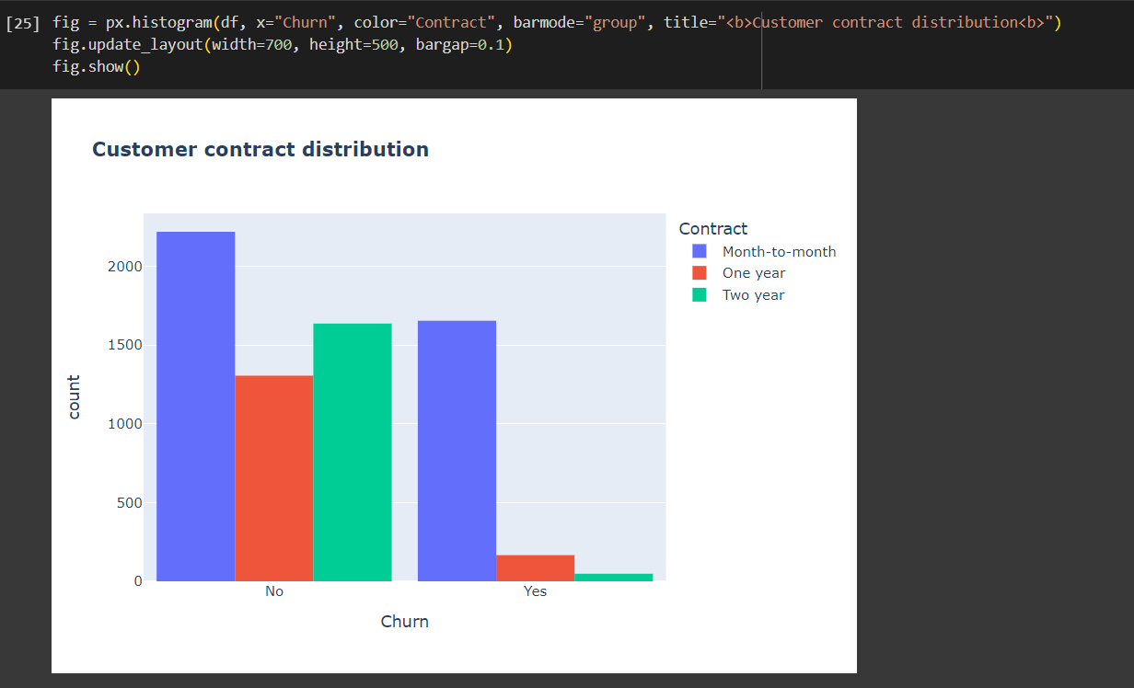

- About 75% of customer with Month-to-Month Contract opted to move out as compared to 13% of customers with One Year Contract and 3% with Two Year Contract.

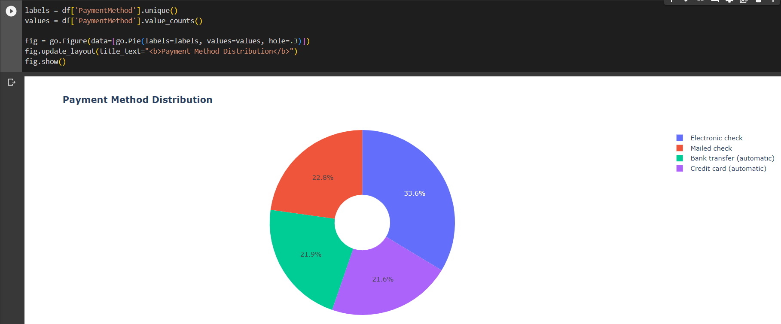

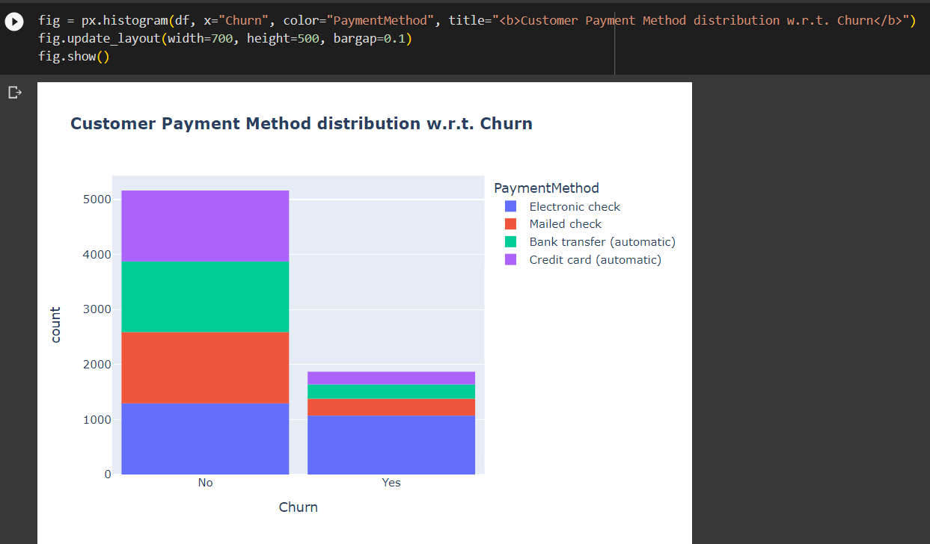

- Major customers who moved out were having Electronic Check as Payment Method.
- Customers who opted for Credit-Card automatic transfer or Bank Automatic Transfer and Mailed Check as Payment Method were less likely to move out.

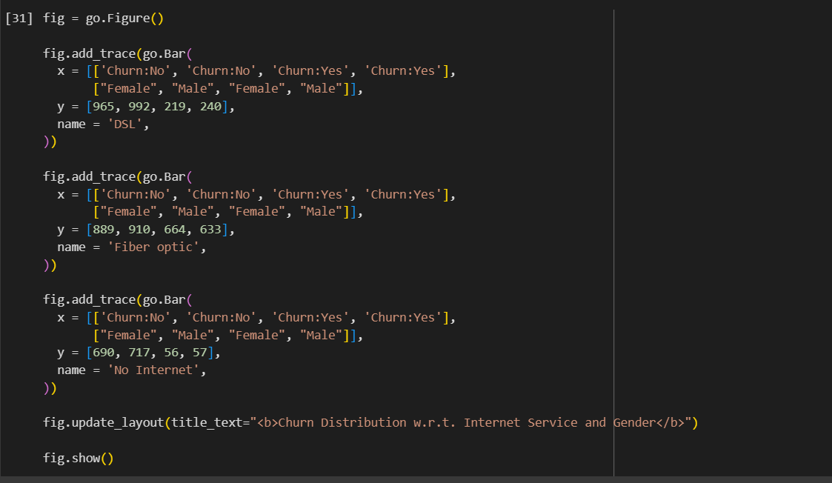
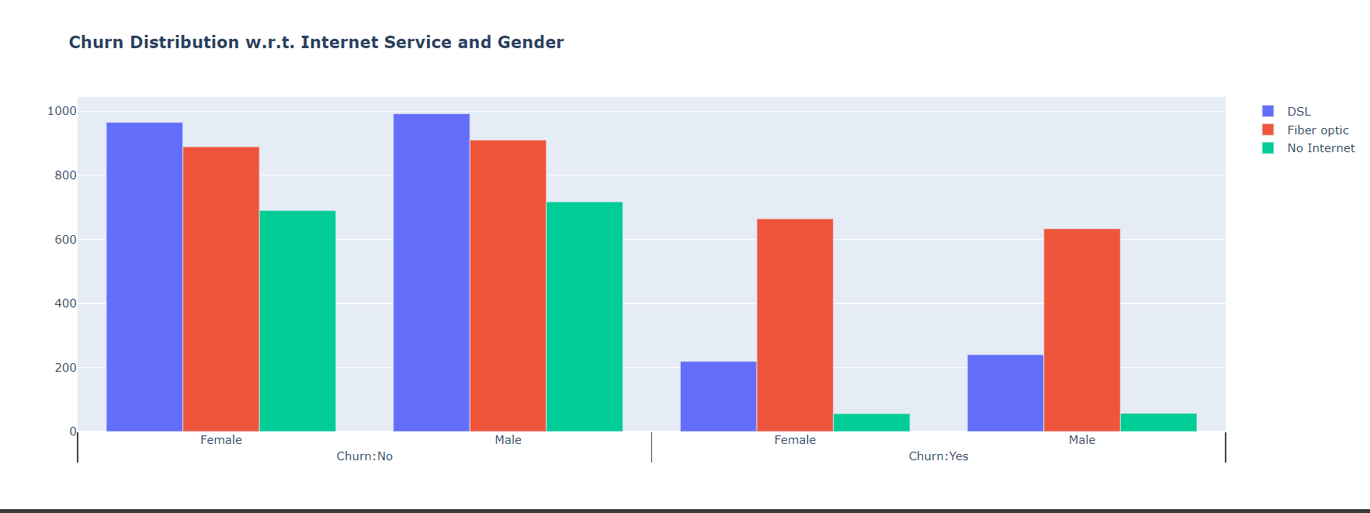

- A lot of customers choose the Fiber optic service and it's also evident that the customers who use Fiber optic have high churn rate, this might suggest a dissatisfaction with this type of internet service.
- Customers having DSL service are majority in number and have less churn rate compared to Fibre optic service.

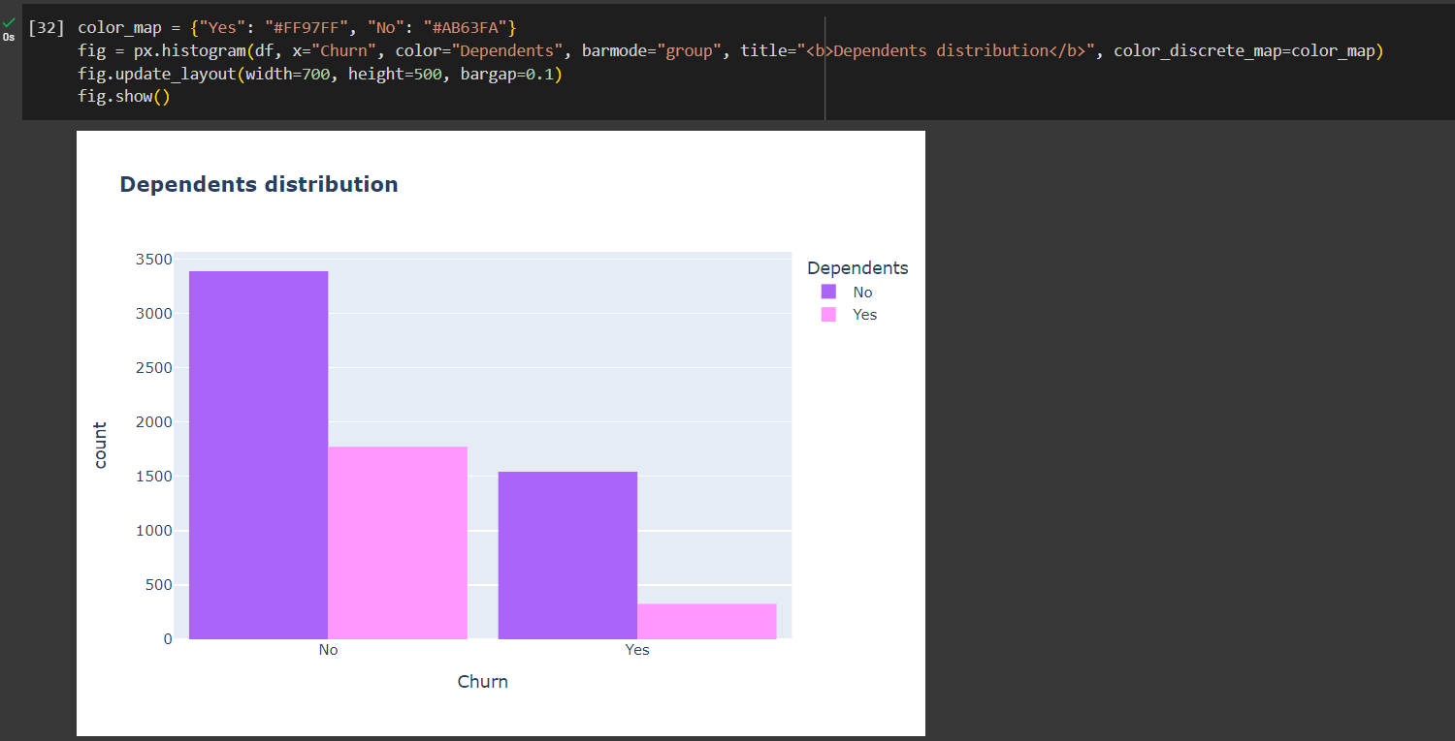

- Customers without dependents are more likely to churn

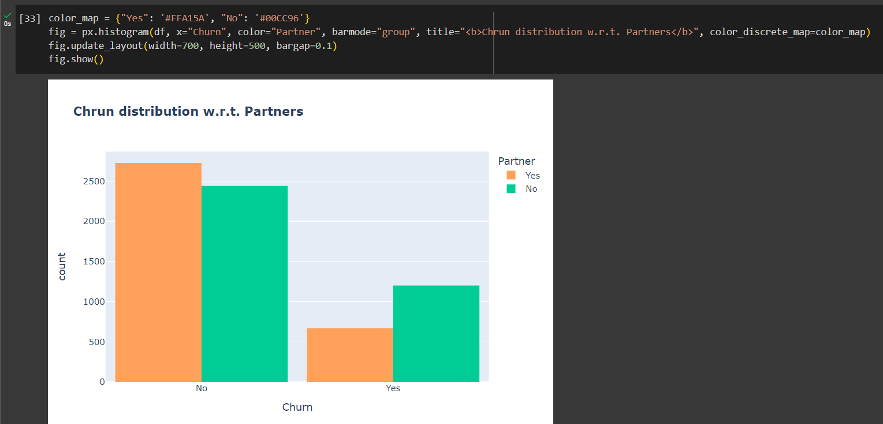

- Customers that doesn't have partners are more likely to churn

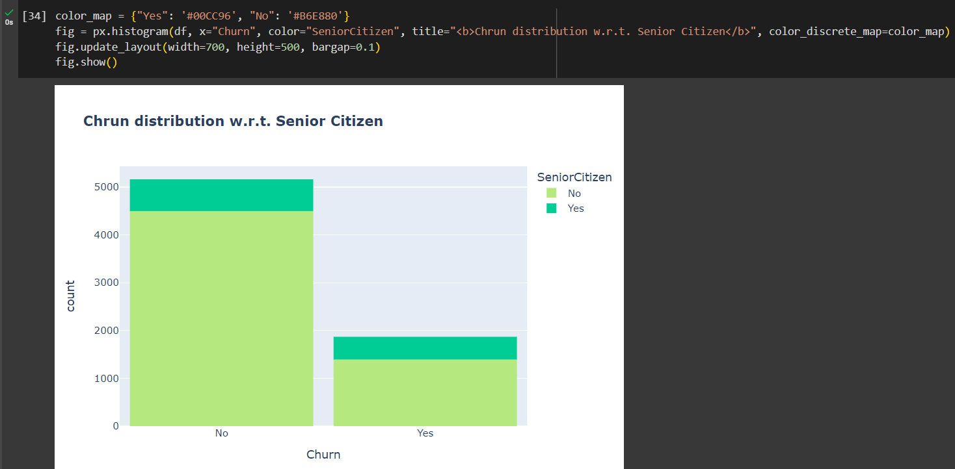

- It can be observed that the fraction of senior citizen is very less.
- Most of the senior citizens churn.

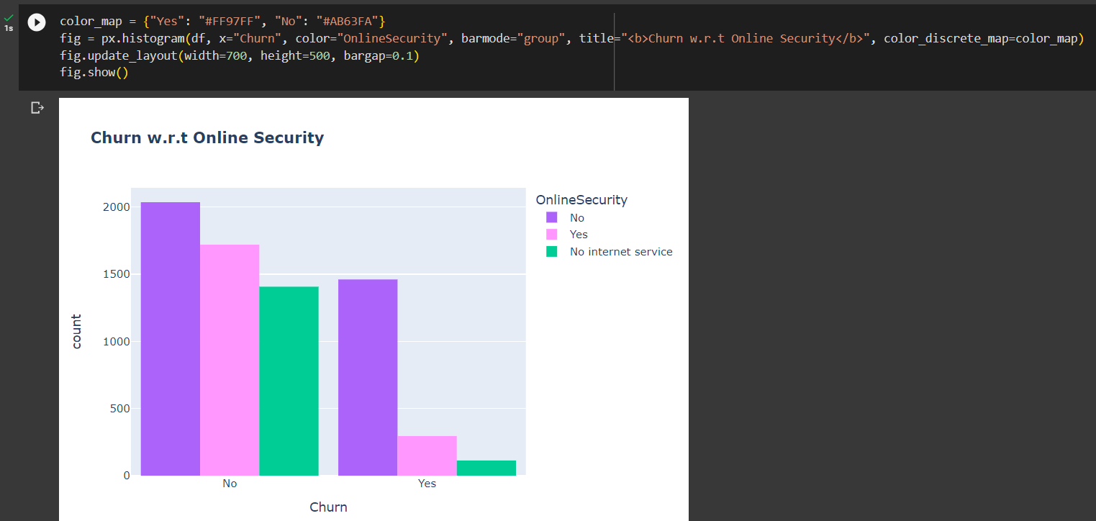

- Most customers churn in the absence of online security.

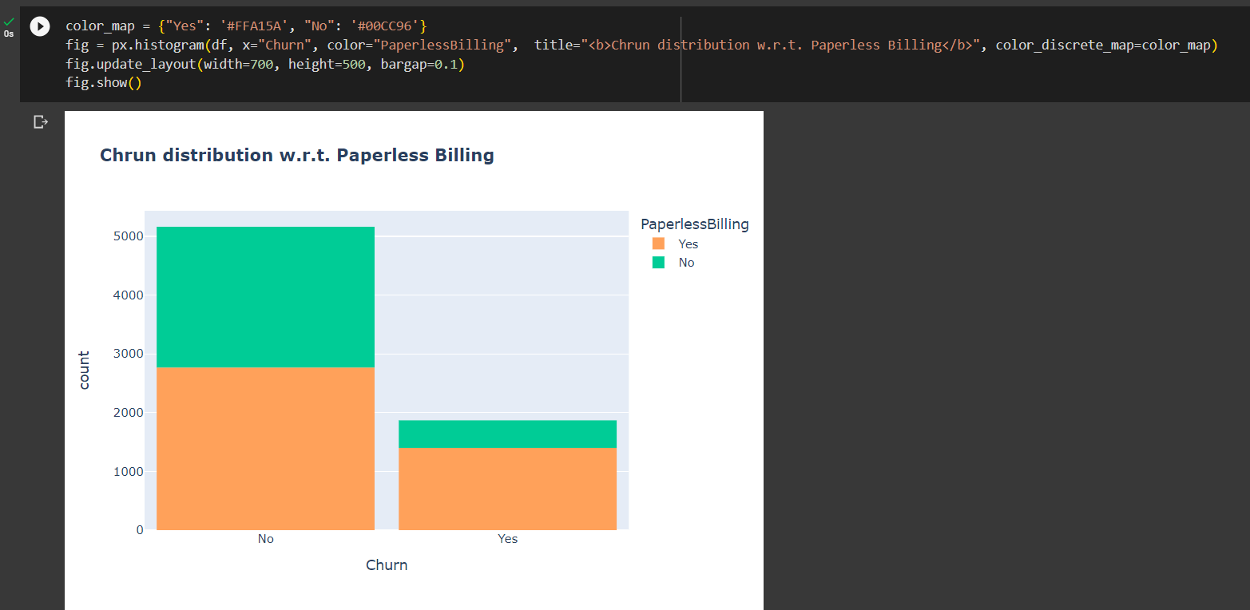

- Customers with Paperless Billing are most likely to churn.

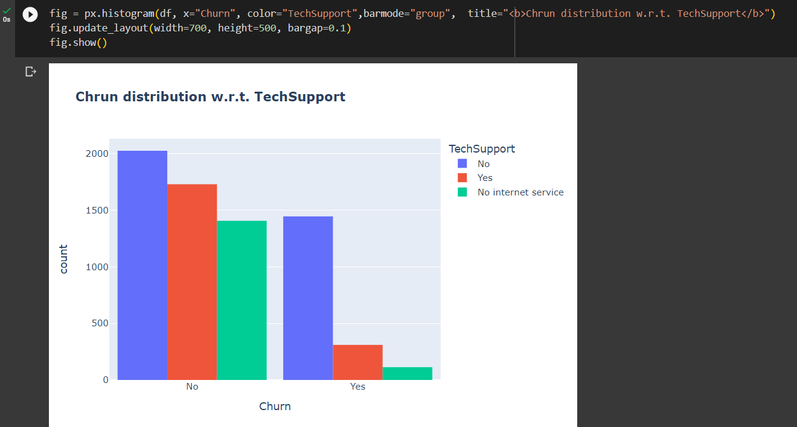

- Customers with no Tech Support are most likely to migrate to another service provider.

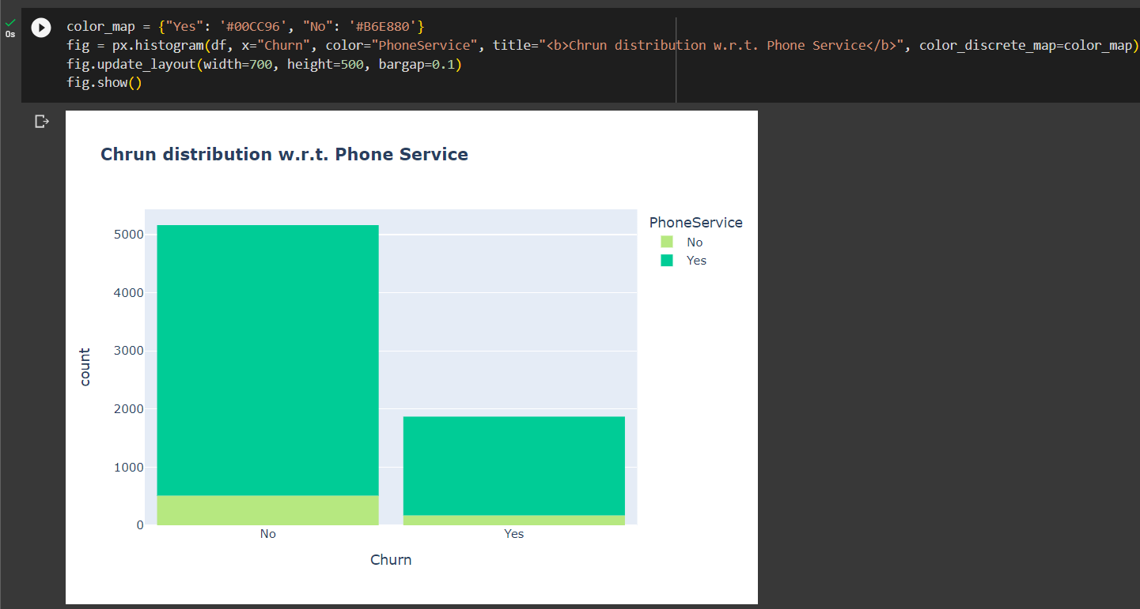

- Very small fraction of customers don't have a phone service and out of that, 1/3rd Customers are more likely to churn.

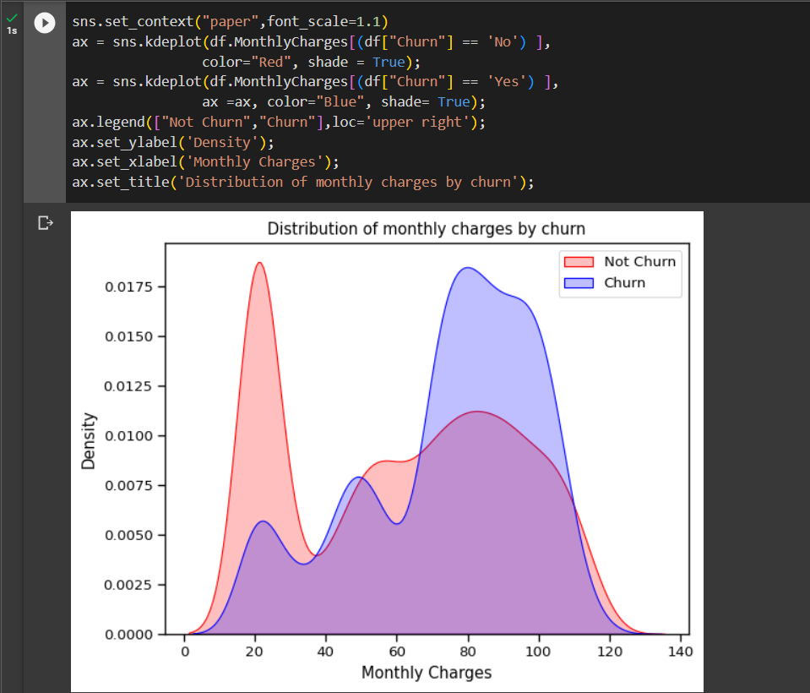

- Customers with higher Monthly Charges are also more likely to churn

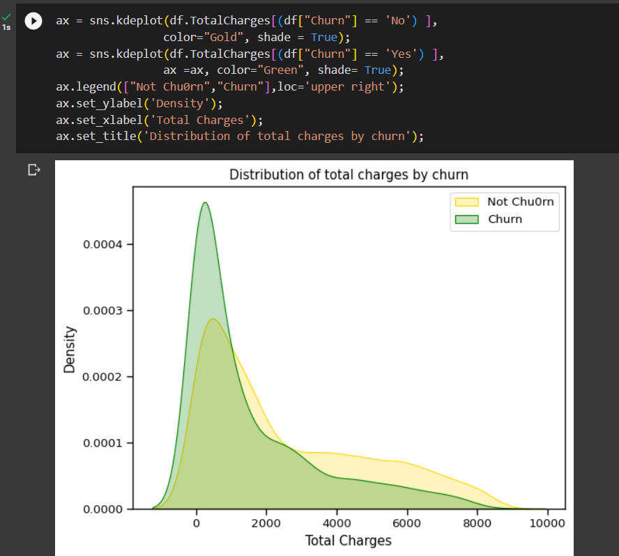

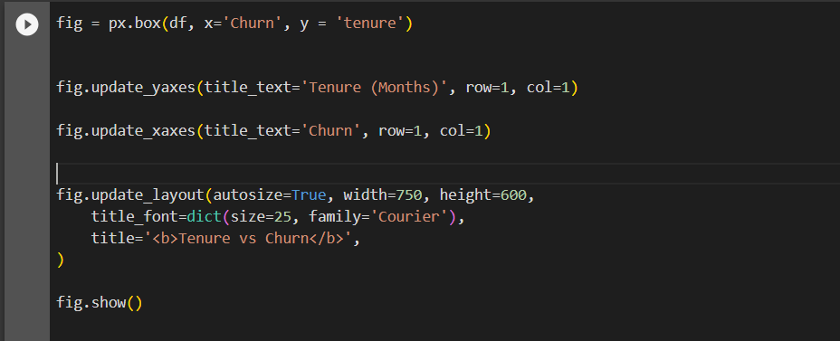
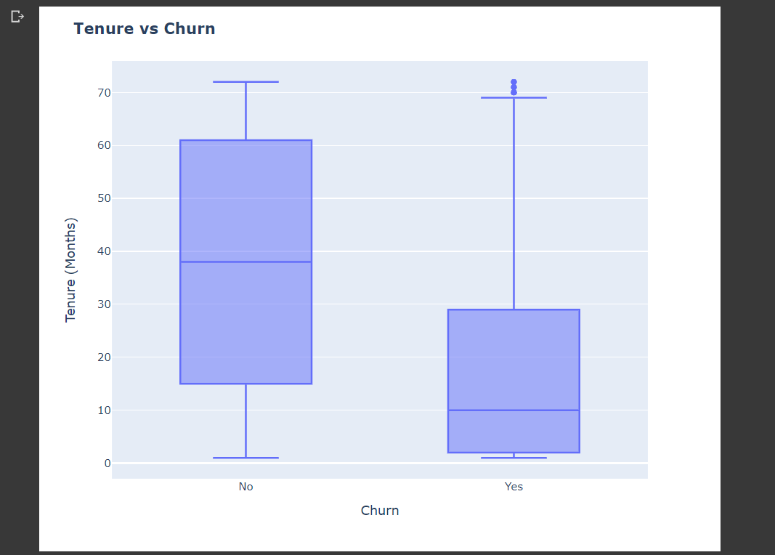

- New customers are more likely to churn.

- QUALITY OF DATA (NOISE, MISSSING VALUES)

FINDING MISSING VALUES :

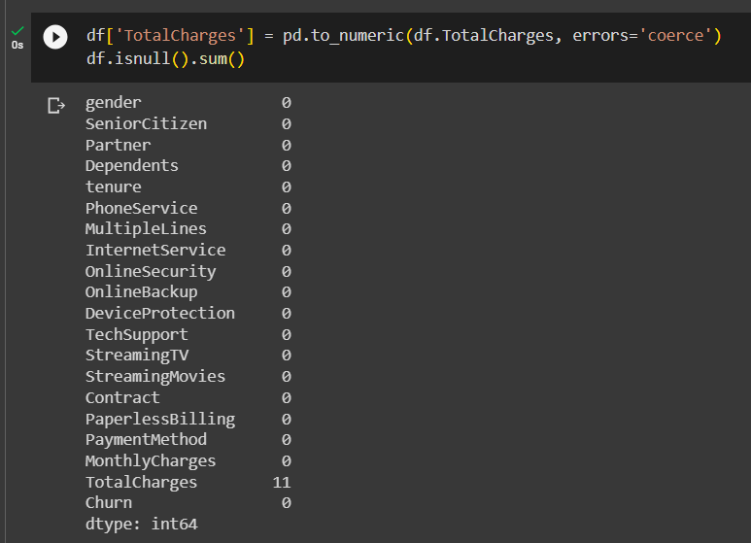

11 MISSING VALUES FOUND


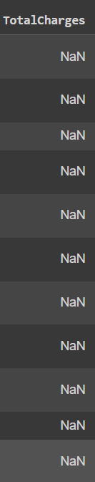

- HANDLING MISSING VALUES

Filling the missing values with the mean.


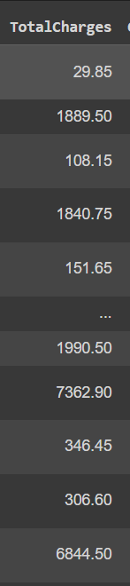

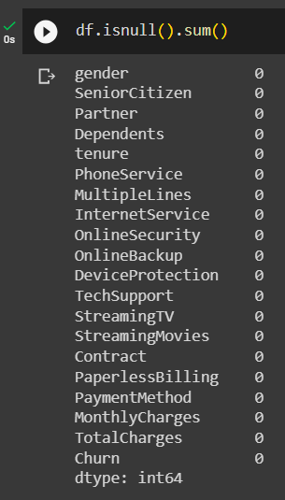

All Null values got removed.

